A000-US-SD-Lakota-Shaman’s Buffalo Calling Wand

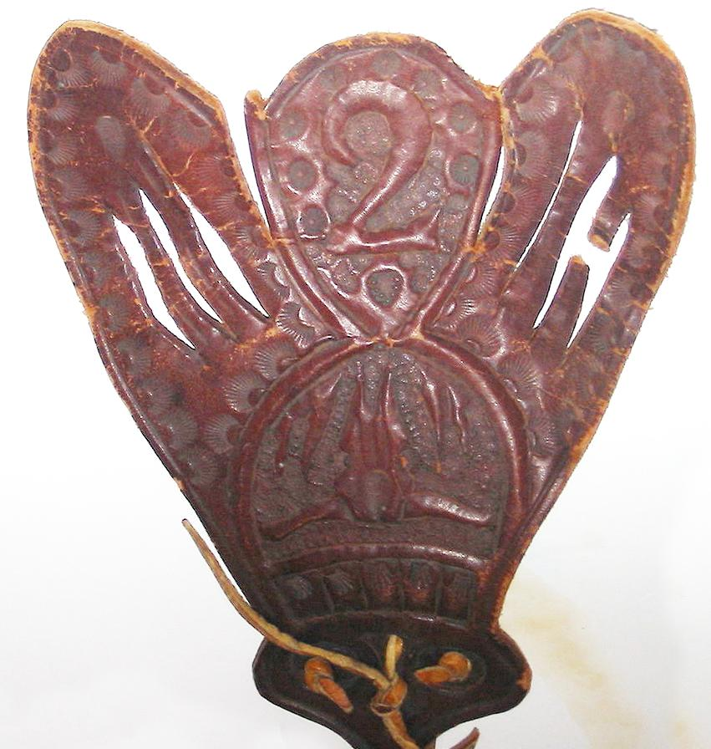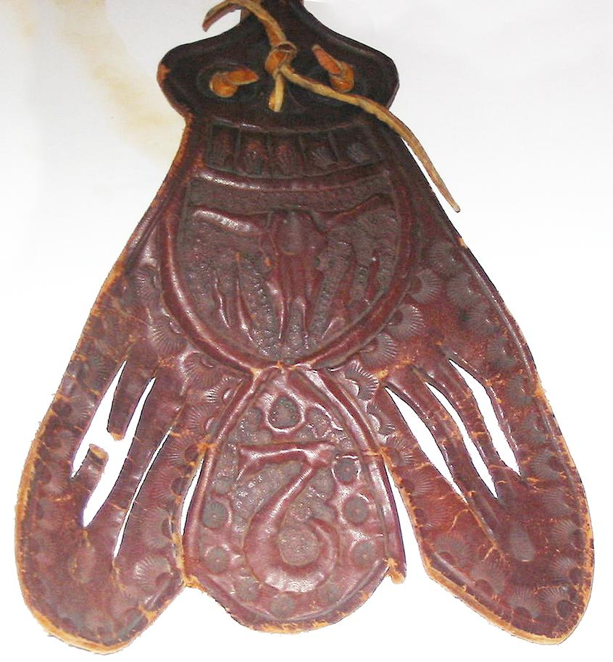

**Case No.: 12**

**Accession No.**

**Formal Label:** Lakota-Shaman’s Buffalo Calling Wand

**Display Description:**

Buffalo Calling Wand in worked brain-tanned leather. The designs show a white buffalo skull, that was the spirit called by the shaman to invoke the finding of herds by the hunters. The upside-down “2” is enigmatic and may be a spirit helper.

**LC Classification:**

**Date or Time Horizon:**

**Geographical Area:**

**Map:**

**GPS coordinates:**

**Cultural Affiliation:**

**Media:**

**Dimensions:**

**Weight:**

**Condition:**

**Provenance:**

**Discussion:**

**References:**